Google Hangouts
Visit: https://hangouts.google.com/
You’ll need a Google account for this. If you don’t have one you can either set one up with a gmail account via https://accounts.google.com/signup/v2/webcreateaccount?flowName=GlifWebSignIn&flowEntry=SignUp

Or you can set one up with your own email via https://accounts.google.com/signup/v2/webcreateaccount?flowName=GlifWebSignIn&flowEntry=SignUp&nogm=true
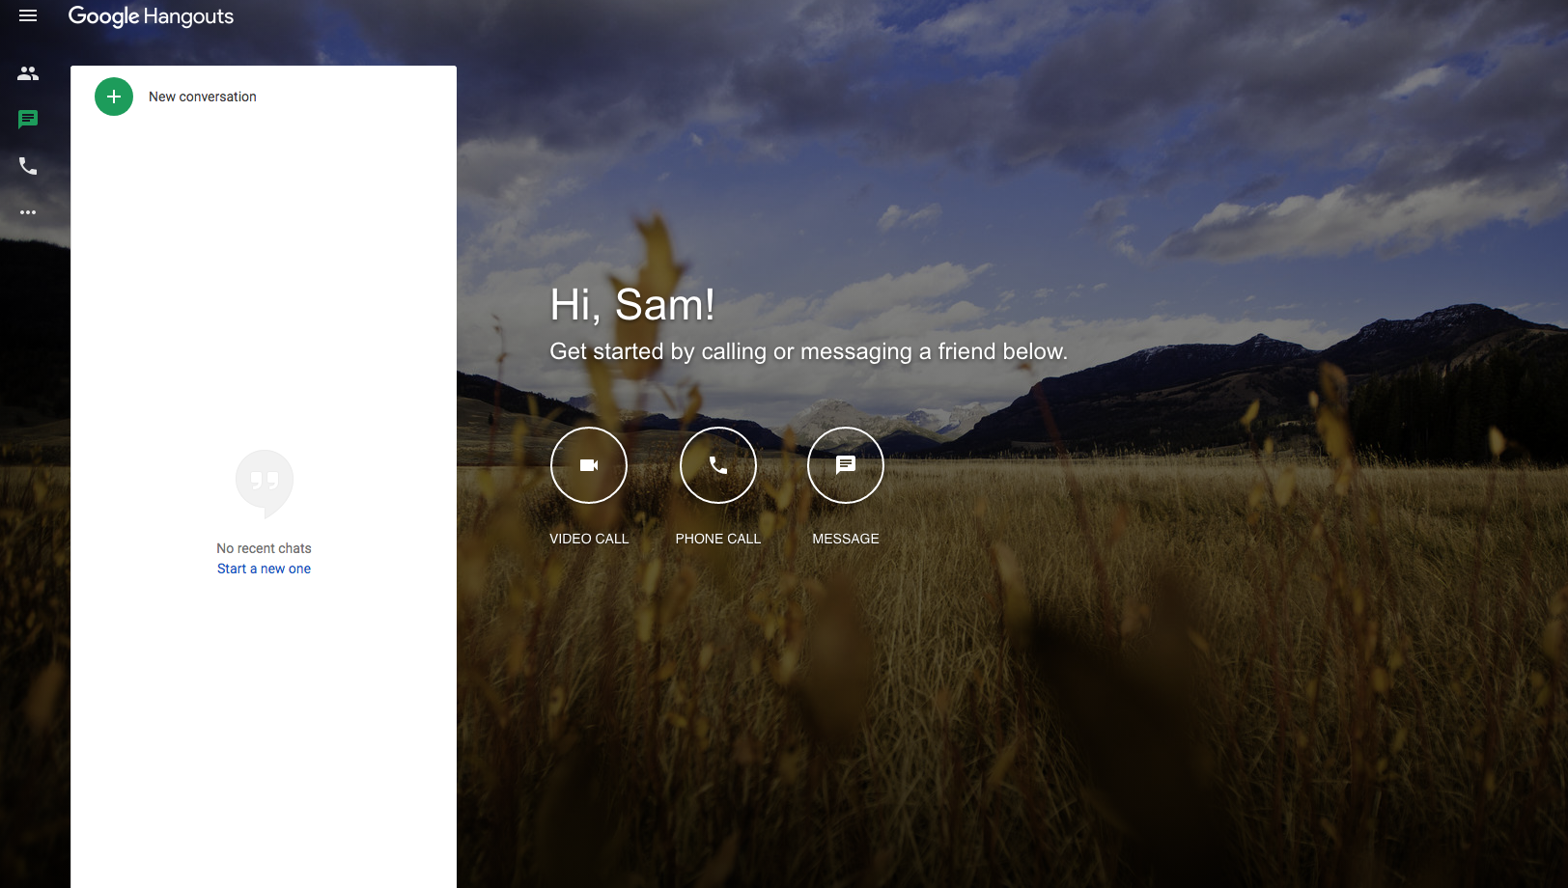

Video Calls
For video click the Video call icon. In the top left corner Google will ask for permission to view your webcam and microphone. Click Allow.

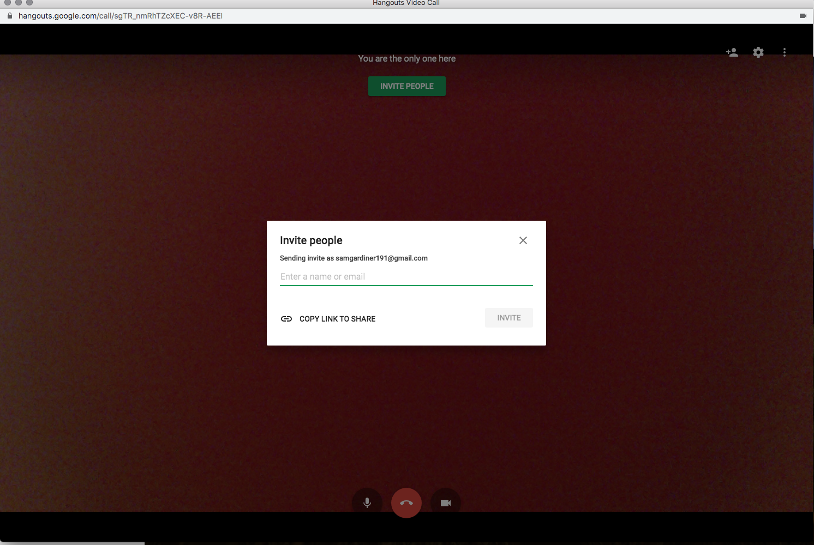
From here you can add people by Name if they are stored on your account, by email or by clicking Copy link to share and sending it directly via email.

If you click the 3 vertical dots in the top right corner you’ll see this menu. Here you can Share screen, Make the video window Fullscreen or open the Chat.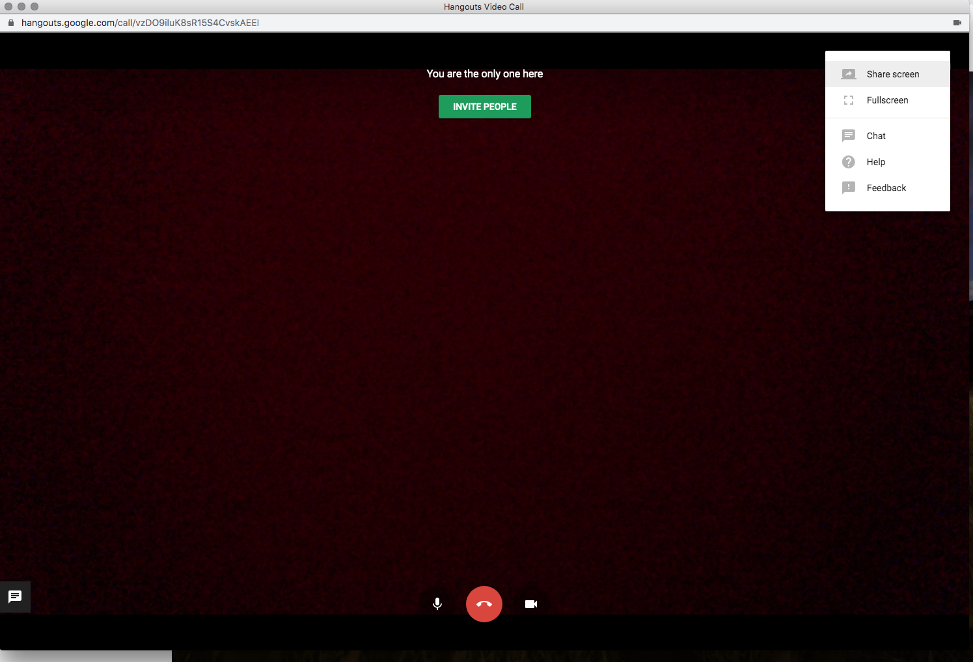Clicking Share screen will open this window
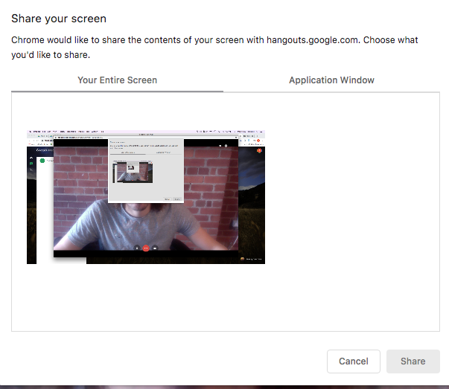
You can choose between sharing your entire screen or a specific window or app, for example just share Microsoft Word.
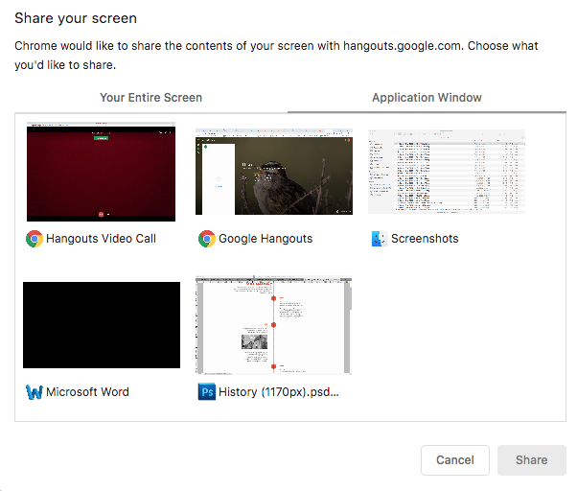

If you click on the Chat option, you can send a message to everyone in the call

If you click on Show messages it’ll open up the window to easily see other people’s messages.
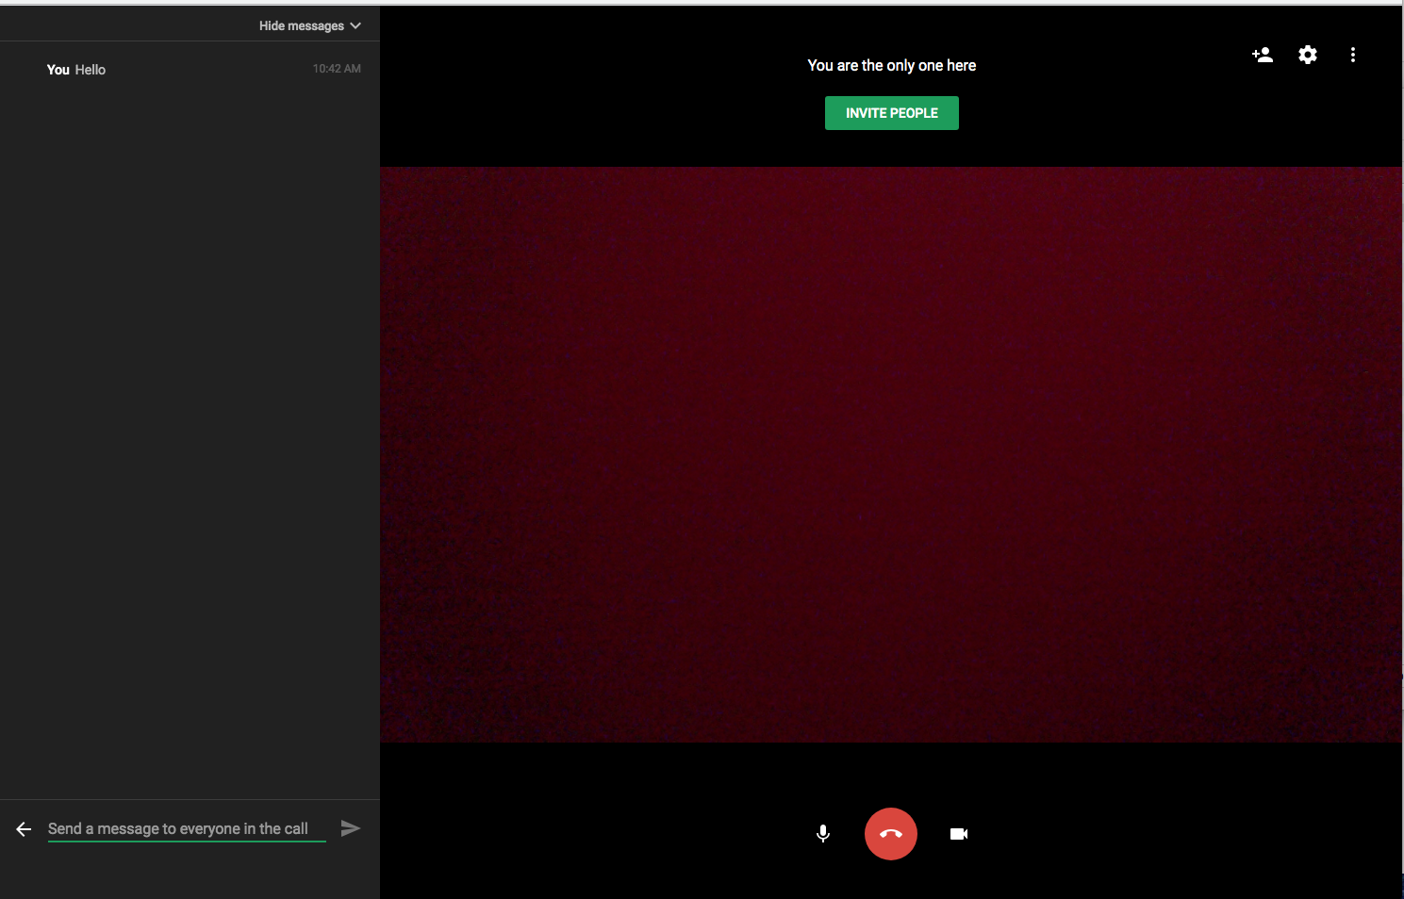

At the bottom you also have three buttons in the middle. The left icon will mute audio. The middle icon will end the chat for you and the right icon will mute the video.

Once people start joining the call, you’ll see them in the bottom right corner. You can fullscreen a specific person by clicking on their video.

Update your Status
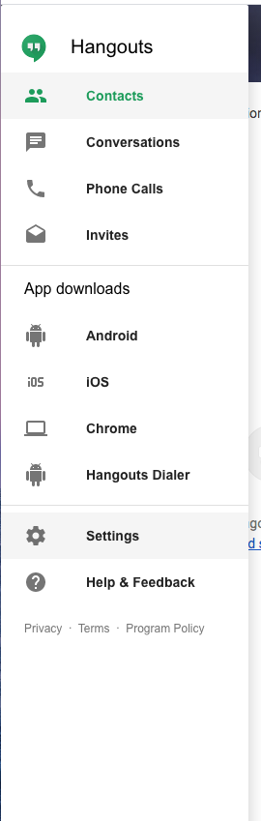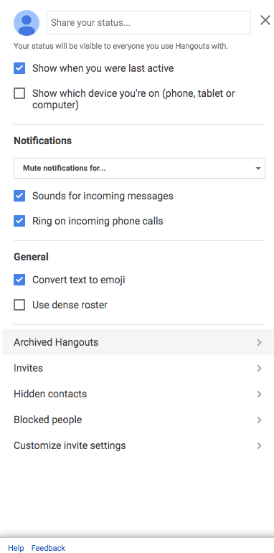
If you click the 3 horizontal lines in the top left corner and click Settings you can update your status for your contacts

Troubleshooting
If you are experiencing issues with the video calls, you can try reducing the quality.
If you click the Cog in the top right corner you’ll see this. Click on Bandwidth and change the Outgoing and Incoming video settings to 320p. This should solve most issues involving video freeze.
